DA 6823

Vishwa Koppisetti

Module 2: Part #1 (35 points)

**Standard Error of the Estimate + Confidence Intervals + the Logic of Hypothesis Testing + Type 1 and Type II errors**

**General Instructions:** In your own words, answer each of the following questions - don’t copy (e.g. cut and paste) some definition out of a book word for word. This is not a group project – you are expected to complete this module on your own. You may refer to text books, online or other sources but not your fellow classmates. If you don’t understand the question, feel free to ask the instructor in class, in office hours or in an email.

1. Explain in your own words in a couple of sentences what a confidence interval is (4 points)

A confidence interval gives an estimated range of values which is likely to include an unknown population parameter, the estimated range being calculated from a given set of sample data. The confidence interval can take any number of probabilities, with the most common being 95% or 99%.

A confidence interval indicates the precision of the estimate and the uncertainty of the interval estimate. The interval estimate could be a 95% confidence interval. That means if the same population is sampled on multiple occasions and interval estimates calculated for each sample, we would expect the true population parameter to fall within the interval estimates 95% of the time.

1. Imagine that you had a random sample of 150 voters and 45% of them said that they would vote for Donald Trump.
   1. Produce a 95% confidence interval around that proportion. Show your work. (6 points)

[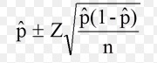](https://www.statisticshowto.datasciencecentral.com/wp-content/uploads/2013/09/confidence-interval-for-a-proportion-1.jpg)

p-hat = 0.45

z=1.96 for 95%, n=150

upper confidence interval for a proportion = 0.45+1.96 √ (0.45 (1-0.45)/150) = **0.5296**

lower confidence interval for a proportion = 0.45-1.96 √ (0.45 (1-0.45)/150) = **0.3703**

Therefore the 95% confidence interval for a proportion of 0.45 out of 150 voters is (0.3703,0.5296)

1. Imagine that you took a random sample of 50 light bulbs and measured how long they lasted. Your experiment shows that the sample mean number of hours is 1150 and the sample standard deviation is 120 hours. Produce a 95% confidence interval around the mean. Show your work. (7 points)

Formula to calculate 95% confidence interval around the mean: x̄ ± z* σ / (√n)

x̄ = 1150, Z = 1.96 for 95% confidence interval, σ = 120, n=50

lower confidence interval = 1150 – 1.96*120/√50 = 1150-1.96*16.97= 1116.74

upper confidence interval = 1150 + 1.96*120/√50 = 1150-1.96*16.97= 1183.26

95% confidence interval around the mean, 1150 is (1116.7, 1183.26)

1. Imagine that the population mean age for UTSA students is 26 and the population standard deviation is 4. Calculate the Z score the data point 24. Show your work (4 points)

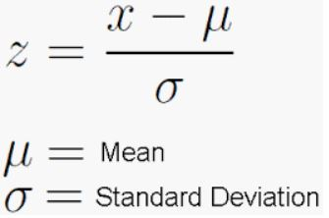

X = 24, Mean = 26, Standard deviation = 4

Z= (24-26)/4

Z=-0.5

Therefore, the Z-score is -0.5

1. Draw a Z curve and mark off the value Z = 1.61. Using a z table what is the area to the right of z=1.61? (4 points)

As we know the area under a normal distribution curve is 1. So, it would be 0.5 to the left and 0.5 to the right

We look up the z-table for z-score 1.61 and find its corresponding probability which is the area to the left of 1.61.

Under 1.6 on Y-axis and 0.01 on X-axis is 0.9463 which is to the left of z=1.61 so to find area towards the right of z=1.61, we subtract 0.9463 from 1(the total area under the curve). Therefore 1-0.9463 = **0.05370(that is 5.3%)** isthe area to the right of z=1.61

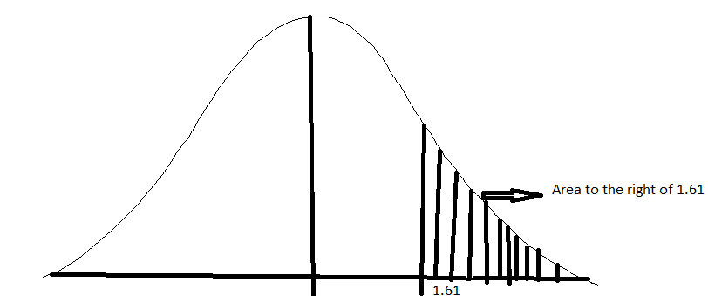

1. Draw a Z curve and mark the point Z=-.8 What is the area to the left of this z score? (4 points)

We look up the z-table for z-score -0.8 and find its corresponding probability which is the area to the left of -0.8

Under -0.8 on Y-axis and 0 on X-axis is **0.21186(that is 21%)** which is area to the left of z=-0.8

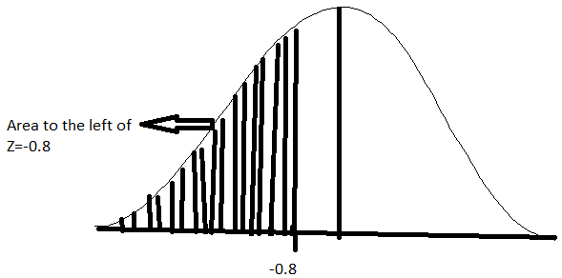

1. Draw a Z curve and mark off the Z score Z= -.34 and then mark off the Z score Z=.66 Now calculate the area under the curve between these two points. Show your work. (6 points).

Area to the left of z=-0.34 is obtained by looking for -0.3 under Y-axis and 0.04 under X-axis which is 0.36693

Similarly, area to the left of z=0.66 is obtained by looking for 0.6 on Y-axis and 0.06 under X-axis which is 0.74537.

Therefore, for area between z=-0.34 and z=0.66 we subtract 0.36693 from 0.74537

0.74537-0.36693 = 0.3785

